Testing Strategy

1.Introduction
This document defines the testing strategy for the DataForge prototype. The purpose of this strategy is to provide a structured approach for verifying the correctness, reliability, performance, and effectiveness of the system throughout the development process.
The DataForge prototype consists of multiple components, including data ingestion, real-time data processing, AI-based analytics, and supporting APIs. As the platform relies on technologies such as Apache Kafka and Apache Spark for real-time data processing, a comprehensive testing approach is required to ensure system stability and data integrity.
This document describes the testing objectives, scope, methodologies, tools, environments, and success criteria that will be used during the testing phase. It covers unit testing, integration testing, performance and load testing, and AI model validation activities. The strategy also defines how testing results will be evaluated to determine whether the prototype meets its functional and non-functional requirements.
The goal of this testing strategy is to establish confidence that the DataForge prototype can operate reliably under expected workloads while maintaining accurate and consistent processing of data throughout the pipeline.

2.Testing Objectives
The primary objective of this testing strategy is to verify that the DataForge prototype functions correctly and reliably under expected operating conditions.
Testing is not only intended to identify defects but also to demonstrate that the system can successfully perform its intended tasks using a well-defined and repeatable testing methodology.
The testing process aims to validate the following objectives:
- Verify that all software components operate as expected.
- Confirm that data can successfully flow through the complete Kafka-to-Spark processing pipeline.
- Ensure that data validation and schema verification mechanisms work correctly.
- Verify that APIs return correct and consistent results.
- Evaluate system behavior under different workloads and data volumes.
- Measure throughput and latency to determine whether performance requirements are met.
- Validate the accuracy and effectiveness of AI models using objective evaluation metrics.
- Establish confidence that the prototype is ready for further development and real-world testing scenarios.
Ultimately, the goal of this testing strategy is to demonstrate that the DataForge prototype can process data accurately, reliably, and efficiently while following industry-standard testing practices.

3.Testing Scope
This section defines the boundaries of the testing activities performed for the DataForge prototype. It identifies which components and functionalities are included in the testing process as well as which elements are outside the scope of this testing strategy.
Clearly defining the testing scope helps ensure that testing efforts remain focused on the core objectives of the project and that all stakeholders have a common understanding of what will and will not be validated during the testing phase.
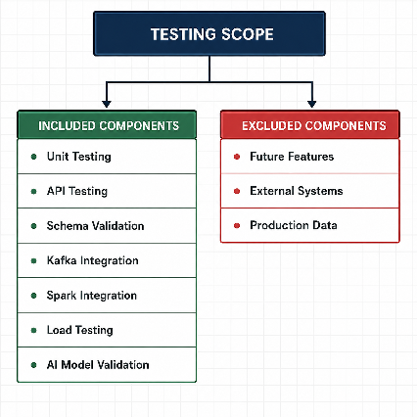
As illustrated in the diagram above, the testing activities focus on the core components of the DataForge prototype, including unit testing, integration testing, performance testing, and AI model validation. These components represent the critical functionality required to evaluate the correctness and reliability of the system.
Elements that are not directly related to the prototype validation, such as future features, external systems, and production data, are excluded from the current testing scope. This ensures that testing efforts remain focused on the objectives and requirements of the prototype phase.

3.1.Components Included in Testing
The components included in the testing scope have been selected based on the core architecture of the DataForge prototype. Since DataForge operates as an end-to-end data processing platform, testing must cover every critical stage of the workflow, from data collection and adaptation to real-time processing and AI-driven analytics.
The selected testing components are designed to verify both individual system modules and the interactions between them. This approach ensures that the platform can correctly ingest, transform, process, and analyze data while maintaining performance, reliability, and data integrity across the entire pipeline.
To better illustrate the relationship between testing activities and the DataForge architecture, the following diagram maps each testing component to the system layer it is primarily intended to validate.
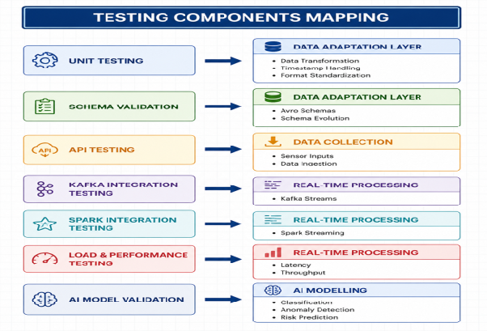
The diagram illustrates the relationship between the testing activities included in the DataForge testing strategy and the corresponding architectural layers of the platform. Each testing component is mapped to the system layer it is primarily intended to validate, ensuring that all critical stages of the DataForge workflow are covered by appropriate testing procedures.
The mapping demonstrates that testing is performed across the entire data pipeline, from data collection and adaptation to real-time processing and AI-based modelling. This approach provides comprehensive validation of both individual system components and the interactions between them, helping ensure data integrity, system reliability, and overall platform performance.

3.2.Components Excluded from Testing
While the testing strategy aims to provide comprehensive coverage of the DataForge prototype, certain components and activities are intentionally excluded from the current testing scope. These exclusions are necessary to maintain focus on validating the core functionality of the prototype and to ensure that testing efforts remain aligned with the project objectives.
On the following diagram, components are considered outside the scope of the current testing phase and will not be formally validated as part of this testing strategy.
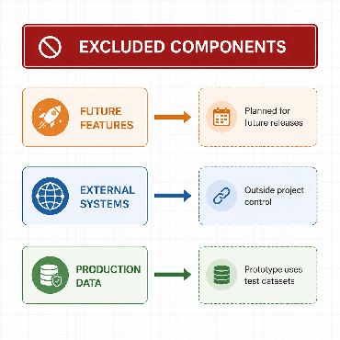
The excluded components represent areas that are either outside the control of the project team or not required for validating the current prototype. Excluding these elements allows testing activities to concentrate on the functionality that is essential for demonstrating the feasibility and performance of the DataForge platform.
Future features, external third-party systems, and production datasets may be considered in later project phases; however, they are not required for evaluating the objectives of the current prototype implementation.

4.Unit Testing Strategy
Unit testing is used to verify the correctness of individual software components before they are integrated into the complete DataForge pipeline. Since the platform relies on multiple processing stages, errors introduced in a single component can propagate throughout the system and affect downstream functionality.
Particular attention is given to data transformation functions, schema validation logic, and API routes. Before data can be transmitted to Apache Kafka, it must be converted into the correct JSON structure and comply with the expected schema requirements. Individual processing functions must also behave consistently and produce reliable outputs under different input conditions.
The objective of unit testing is to detect issues as early as possible and ensure that each component performs its intended function before integration and end-to-end testing are performed.

4.1.Testing Framework(pytest)
Pytest has been selected as the primary framework for unit testing within the DataForge prototype. As the platform is primarily developed using Python-based technologies, pytest provides a simple and efficient environment for creating, organizing, and executing automated tests.
The framework enables developers to verify the behavior of individual functions, schema validators, and API routes in a repeatable manner. It also supports automated test execution, detailed error reporting, and integration with continuous integration and deployment (CI/CD) workflows.
By using pytest, testing activities can be performed consistently throughout the development lifecycle, helping identify defects early and ensuring that software components meet their expected functionality before integration testing begins.
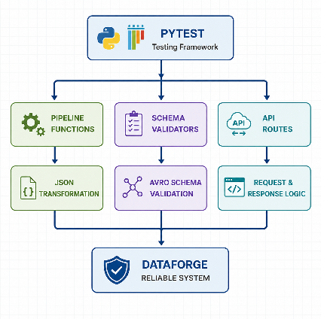
The diagram illustrates how pytest supports the unit testing process within the DataForge prototype. Rather than testing the entire platform as a single system, pytest is used to validate individual software components independently, including pipeline functions, schema validators, and API routes.
This approach is particularly important for DataForge because the platform depends on reliable data processing before information reaches the Apache Kafka streaming infrastructure. Data must first be transformed into the correct JSON format, validated against the required schemas, and successfully handled by the API layer. By testing these components individually, defects can be identified and resolved before they propagate to downstream stages of the pipeline.
Pytest was selected as the primary testing framework because it provides an efficient and scalable environment for automated testing within Python-based applications. Its ability to execute repeatable tests, generate detailed reports, and support continuous development practices makes it well suited for validating the core functionality of the DataForge prototype.

4.2.Pipeline Function Testing
Pipeline function testing focuses on validating the individual processing functions that prepare data for transmission through the DataForge pipeline. Since the platform relies on accurate and consistent data processing, any errors introduced during transformation or validation can affect downstream components such as Apache Kafka, Spark Streaming, and AI models.
The primary objective of this testing activity is to ensure that data is correctly transformed, formatted, and validated before entering the streaming infrastructure. Special attention is given to JSON conversion, timestamp handling, data normalization, and other preprocessing operations that are required for successful pipeline execution.
Each pipeline function will be tested independently using predefined input datasets and expected outputs. Test cases will include both valid and invalid inputs to verify that functions behave correctly under normal conditions and appropriately handle unexpected or malformed data.
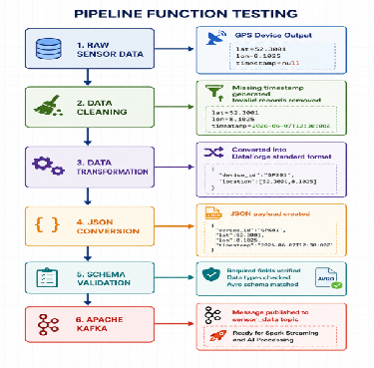
The diagram above illustrates the journey of data through the DataForge pipeline before it enters the Apache Kafka streaming infrastructure. Each stage performs a specific operation that prepares the data for downstream processing, including cleaning, transformation, JSON conversion, and schema validation.
Pipeline function testing is a critical part of the testing strategy because the reliability of the entire platform depends on the correctness of these intermediate processing steps. If data is incorrectly transformed, improperly formatted, or fails schema requirements, errors may propagate throughout the pipeline and negatively impact Kafka ingestion, Spark Streaming operations, and AI model performance.
For this reason, each pipeline function is tested independently to verify that data is processed correctly at every stage of its journey. By validating the expected inputs and outputs of individual functions, defects can be identified early and resolved before they affect the broader DataForge ecosystem. This approach improves data quality, system reliability, and confidence in the overall platform architecture.

4.3.Schema Validation Testing
Schema validation testing focuses on verifying that all data records conform to the predefined structural and formatting requirements before they are transmitted through the DataForge pipeline. Since the platform processes large volumes of streaming data, maintaining a consistent data structure is essential for reliable communication between system components.
The primary objective of schema validation testing is to ensure that incoming and transformed data contain all required fields, use the correct data types, and comply with the expected schema definitions. This validation process helps prevent malformed or incomplete records from entering Apache Kafka and causing downstream processing errors.
By enforcing schema consistency, DataForge can maintain data integrity throughout the pipeline and ensure that downstream services such as Spark Streaming and AI-based analytics receive valid and predictable inputs.
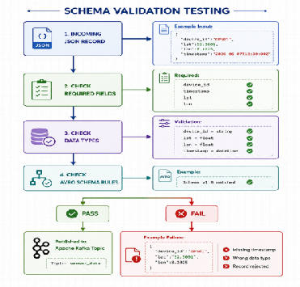
The diagram illustrates the schema validation process used within the DataForge pipeline to ensure that incoming data meets all structural and formatting requirements before being published to Apache Kafka. Each record is evaluated against a series of validation checks, including required field verification, data type validation, and compliance with predefined Avro schema rules.
Schema validation testing plays a critical role in the overall testing strategy because it serves as a quality control mechanism for the entire platform. Streaming systems such as DataForge depend on consistent and predictable data structures. If malformed records are allowed to enter the pipeline, they can cause processing failures, inaccurate analytics, and unreliable AI model outputs.
For this reason, schema validation testing is designed to verify both successful and failure scenarios. Valid records must successfully pass all validation stages and be published to Apache Kafka, while invalid records must be correctly identified, logged, and rejected. By enforcing these validation rules, DataForge maintains data integrity, improves system reliability, and reduces the risk of downstream processing errors.

4.4.API Route Testing
API route testing focuses on verifying the correctness and reliability of the endpoints used within the DataForge prototype. APIs serve as the communication layer between users, services, and internal platform components, making them a critical part of the overall system architecture.
The primary objective of API route testing is to ensure that requests are correctly processed and that responses are returned in the expected format. Testing activities will verify endpoint accessibility, response structures, status codes, input validation, and error handling behavior.
Both valid and invalid requests will be evaluated to confirm that API routes behave consistently under different conditions. This helps ensure that downstream services receive accurate information and that unexpected inputs do not compromise system stability.
By validating API functionality at an early stage, DataForge can reduce integration issues and improve the reliability of communication between platform components.
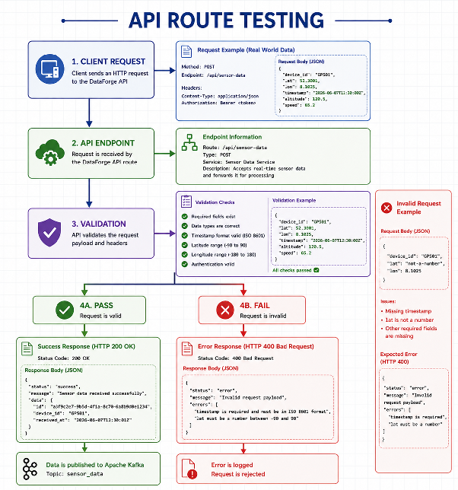
The diagram above illustrates the API route testing process used within the DataForge prototype. It demonstrates how incoming client requests are received by API endpoints, validated against predefined rules, and either accepted or rejected based on their compliance with the platform requirements. The diagram also highlights both successful and unsuccessful request scenarios, including the expected HTTP responses and system behavior in each case.
API route testing is an essential component of the overall testing strategy because APIs serve as the primary communication interface between external systems and the DataForge platform. Every piece of data entering the system must pass through one or more API endpoints before it can be processed, validated, and forwarded to downstream services.
For this reason, API route testing verifies not only that valid requests are accepted and processed correctly, but also that invalid requests are detected, rejected, and logged appropriately. This helps prevent malformed or incomplete data from entering the pipeline and ensures that downstream components such as Apache Kafka, Spark Streaming, and AI-based analytics receive reliable and consistent inputs.
By validating endpoint behavior, request handling, response generation, and error management, API route testing improves system reliability, strengthens data quality controls, and reduces the risk of failures propagating throughout the DataForge architecture.

4.5.Code Coverage Targets
Code coverage targets define how much of the DataForge codebase should be executed by automated tests. In this context, code coverage does not mean that a project stage is tested only in general terms; instead, it measures how much of the actual source code, logic branches, and executable paths are covered by test cases.
For the DataForge prototype, code coverage is important because the platform depends on several critical processing components. Functions responsible for data cleaning, JSON transformation, schema validation, and API request handling must be tested with both valid and invalid inputs to ensure that different execution paths are verified.
The following coverage targets will be used as a guideline: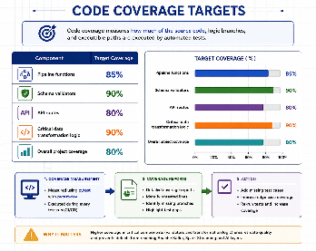
The coverage targets shown in the diagram reflect the relative importance of each component within the DataForge architecture. Components responsible for schema validation and critical data transformation have the highest coverage targets (90%) because they act as quality control points before data enters the streaming infrastructure.
For example, if a transformation function incorrectly formats GPS coordinates, timestamps, or sensor values, the resulting JSON payload may still reach Apache Kafka but contain inaccurate information. Similarly, if schema validation logic fails to detect missing fields or incorrect data types, malformed records may be accepted and propagated throughout the pipeline. Such errors can negatively impact Spark Streaming operations, AI model predictions, and downstream analytics.
Coverage measurement will be performed using pytest together with pytest-cov. The generated coverage reports will identify code paths, logic branches, and functions that are not currently exercised by automated tests. These reports will be reviewed throughout development to detect untested scenarios, improve edge-case coverage, and ensure that critical DataForge components achieve their target coverage levels.
By establishing measurable coverage objectives, the project can systematically verify that the most important processing logic is thoroughly tested and that defects are detected before they affect the broader DataForge ecosystem.

5.Integration Testing Strategy
Integration testing focuses on verifying that the main components of the DataForge prototype work correctly together as a complete data processing pipeline. While unit testing validates individual functions and modules, integration testing evaluates the communication and data flow between system components.
The primary objective of integration testing is to confirm that data can move successfully from the data collection layer to Apache Kafka, then through Spark Streaming, and finally toward downstream analytics or AI processing components. This ensures that the different layers of the platform are not only correct individually, but also compatible with each other when connected.
Integration tests will validate message publishing, message consumption, data format compatibility, pipeline continuity, and error handling between connected components. This testing phase is essential for proving that the DataForge prototype can operate as an end-to-end streaming data platform.

5.1.Kafka Integration Testing
Kafka integration testing focuses on verifying the communication between DataForge components and the Apache Kafka messaging infrastructure. Since Kafka acts as the central message broker within the platform, reliable message delivery is essential for ensuring continuous data processing and real-time analytics.
The primary objective of this testing activity is to confirm that validated data records can be successfully published to Kafka topics and subsequently consumed by downstream services. Testing will verify message delivery, topic configuration, serialization compatibility, and message integrity throughout the transmission process.
Integration tests will be performed using realistic data samples that simulate actual sensor and telemetry data. Both successful and failure scenarios will be evaluated to ensure that the platform behaves correctly under different operating conditions.
By validating Kafka integration, DataForge can ensure reliable communication between the data ingestion layer and downstream processing components such as Spark Streaming and AI-based analytics.
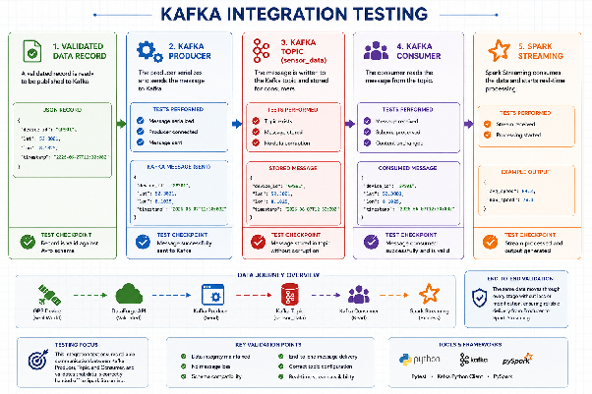
The diagram illustrates the complete journey of a validated data record as it moves through the Kafka integration layer of the DataForge platform. Beginning with a validated JSON record, the data is serialized by a Kafka producer, published to the designated Kafka topic, consumed by downstream services, and finally processed by Spark Streaming. At each stage, integration tests verify that the data remains consistent, complete, and compatible with the next component in the pipeline.
Kafka integration testing is a critical part of the DataForge testing strategy because Apache Kafka serves as the central communication backbone between the platform’s processing layers. Even if individual components function correctly in isolation, failures in message transmission, serialization, topic configuration, or consumer processing can disrupt the entire data pipeline. For this reason, integration tests focus not only on successful message delivery but also on data integrity, schema preservation, and end-to-end communication reliability.
The visualized data journey demonstrates that the same sensor record is tracked throughout the entire integration process. This allows the project team to verify that no information is lost, modified, or corrupted as data moves from the producer to the consumer and ultimately into Spark Streaming. By validating each stage of this communication flow, DataForge can ensure reliable real-time processing, maintain high data quality standards, and provide trustworthy inputs for downstream analytics and AI-driven decision-making.

5.2.Spark Integration
Spark integration testing focuses on verifying the interaction between Apache Kafka and Apache Spark Streaming within the DataForge platform. After data has been successfully delivered through Kafka, Spark is responsible for consuming, processing, aggregating, and transforming the incoming data streams in real time.
The primary objective of this testing activity is to ensure that Spark Streaming can correctly consume Kafka messages and execute the required processing logic without data loss or corruption. Testing activities will verify stream consumption, aggregation accuracy, filtering operations, feature extraction processes, and output generation.
Integration tests will use realistic sensor and telemetry datasets that simulate real-world operating conditions. Both normal and abnormal data scenarios will be evaluated to confirm that Spark can process incoming streams reliably and produce accurate results.
By validating Spark integration, DataForge can ensure that real-time processing functions operate correctly and that downstream analytics and AI components receive high-quality processed data.
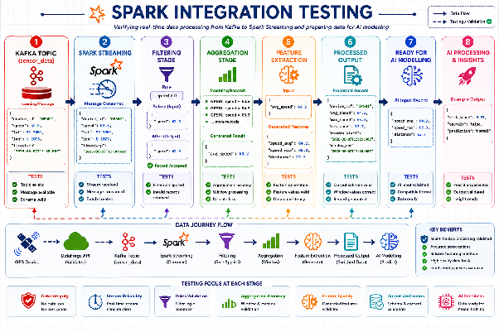
The diagram illustrates the complete processing journey of a real-world sensor record as it moves through Apache Spark Streaming within the DataForge platform. After being successfully consumed from the Kafka topic, the data passes through multiple processing stages including filtering, aggregation, feature extraction, and output generation before becoming ready for AI-driven analytics and prediction tasks.
Unlike Kafka integration testing, which focuses on reliable message delivery, Spark integration testing verifies that the incoming data is processed correctly and transformed into meaningful information. The visualized data journey demonstrates how a raw sensor record is progressively enriched throughout the pipeline. At each stage, integration tests validate processing accuracy, data consistency, schema compliance, and the correctness of generated outputs.
Spark integration testing is a critical component of the DataForge testing strategy because Spark represents the platform's primary real-time processing engine. Any errors in filtering rules, aggregation calculations, or feature extraction logic can directly impact downstream analytics and AI model performance. Even if data is successfully delivered through Kafka, incorrect processing within Spark may result in inaccurate predictions, unreliable anomaly detection, and misleading business insights.
By validating every transformation step shown in the diagram, DataForge ensures that real-time data streams are processed accurately, that generated features remain trustworthy, and that AI models receive high-quality inputs. This provides confidence that the platform can support reliable real-time analytics and data-driven decision-making under realistic operating conditions.

5.3.Kafka-to-Spark Pipeline
Kafka-to-Spark validation focuses on verifying the integrity and consistency of data as it moves between Apache Kafka and Apache Spark Streaming within the DataForge platform. While previous integration tests verify Kafka message delivery and Spark processing independently, this validation stage ensures that data is transferred correctly between the two systems without loss, corruption, or unintended modification.
The primary objective of this testing activity is to confirm that records published to Kafka topics are consumed by Spark Streaming exactly as expected. Validation tests will compare message content, schema structure, field values, and record counts between Kafka and Spark to ensure consistency throughout the transfer process.
Realistic sensor and telemetry datasets will be used to verify that messages remain intact during transmission and that Spark receives all required information for downstream processing. Both normal operating conditions and failure scenarios will be evaluated to identify potential synchronization or communication issues between the two platforms.
By validating the Kafka-to-Spark data flow, DataForge can ensure reliable end-to-end stream processing and maintain confidence in the quality of data used for analytics and AI-driven decision-making.
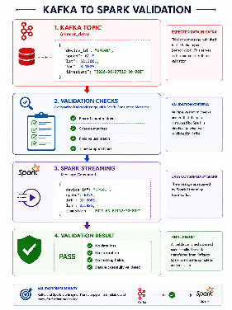
The diagram illustrates the validation process used to verify data consistency between Apache Kafka and Apache Spark Streaming within the DataForge platform. During this stage, the message published to the Kafka topic is compared directly with the message consumed by Spark Streaming. Validation checks are performed to ensure that record counts, schema structures, field values, and timestamps remain identical throughout the transfer process.
Kafka-to-Spark validation is a critical component of the DataForge testing strategy because it serves as the verification point between data transmission and data processing. While Kafka integration testing confirms that messages can be successfully delivered and Spark integration testing verifies that Spark can process incoming streams correctly, Kafka-to-Spark validation ensures that the exact data published by Kafka is the same data received by Spark.
This validation process helps identify potential issues such as message loss, schema mismatches, field corruption, serialization problems, or synchronization errors between the two platforms. Even small inconsistencies introduced during transmission can affect downstream aggregations, feature extraction processes, and AI model predictions.
By validating the complete transfer path shown in the diagram, DataForge can ensure that real-time data streams remain accurate, complete, and reliable before entering the processing stages of the platform. This provides confidence that Spark Streaming operates on trustworthy data and that downstream analytics and AI-driven decision-making are based on consistent information.

5.4.End-to-End Test Scenarios
End-to-end testing validates the complete DataForge pipeline by verifying that data can successfully travel through all major system components from ingestion to final output. Unlike unit and integration testing, which focus on individual components or component interactions, end-to-end testing evaluates the behavior of the platform as a complete system.
The primary objective of this testing activity is to ensure that data is correctly collected, validated, transmitted, processed, and delivered to downstream analytics and AI components without loss, corruption, or unexpected behavior. End-to-end tests simulate realistic operating conditions and verify that all layers of the DataForge architecture work together as intended.
By executing complete data flow scenarios, DataForge can validate the reliability of the entire platform and ensure that real-world sensor data can successfully progress from the data collection layer to AI-driven analytics and decision-making processes.
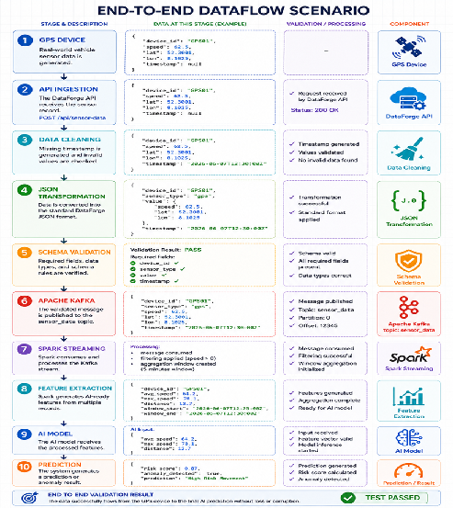
The diagram illustrates a complete end-to-end test scenario within the DataForge platform, following a real-world sensor record from its initial generation at a GPS device through every major processing layer until a final AI-driven prediction is produced. The visualized data journey demonstrates how data is collected, validated, transformed, transmitted, processed, enriched, and ultimately converted into actionable insights.
Unlike unit testing and integration testing, which focus on individual components or specific system interactions, end-to-end testing evaluates the entire platform as a single operational workflow. Each stage shown in the diagram represents a critical checkpoint within the DataForge architecture, where data quality, processing accuracy, schema compliance, and communication reliability are continuously verified.
End-to-end testing is one of the most important elements of the DataForge testing strategy because it provides evidence that all system components work together successfully under realistic operating conditions. A component may function correctly in isolation, and individual integrations may pass their respective tests, yet failures can still occur when the complete pipeline is executed as a single process. End-to-end scenarios are designed to identify these system-level issues before deployment.
The illustrated workflow validates that a real-world sensor record can successfully progress through API ingestion, data cleaning, JSON transformation, schema validation, Apache Kafka, Spark Streaming, feature extraction, and AI processing without data loss, corruption, or unexpected behavior. By verifying the complete lifecycle of a record, DataForge can ensure that downstream analytics and AI-driven decisions are based on accurate, complete, and trustworthy information.
Successful execution of this scenario demonstrates that the platform is capable of supporting reliable real-time data processing and provides confidence that the entire DataForge architecture functions as an integrated end-to-end solution.

6.Performance and Load Testing
Performance and load testing evaluates the ability of the DataForge platform to process large volumes of data efficiently and reliably under different operating conditions. While previous testing activities focused on functional correctness, integration reliability, and end-to-end data flow validation, performance testing focuses on system responsiveness, scalability, and stability under increasing workloads.
The primary objective of this testing phase is to determine whether DataForge can sustain real-time data processing requirements while maintaining acceptable throughput, latency, and reliability. Testing activities will simulate realistic data ingestion scenarios and progressively increase system load to evaluate how the platform behaves under both normal and high-demand conditions.
Performance and load testing will assess the capacity of key components including API endpoints, Apache Kafka, Spark Streaming, and downstream processing services. The collected metrics will be used to identify potential bottlenecks, validate performance targets, and ensure that the platform can support real-world deployment scenarios.
The following sections describe the selected load testing tools, the methodology used for throughput and latency measurements, and the performance criteria that will be used to evaluate the DataForge prototype.

6.1.Load Testing Tool Section
Selecting an appropriate load testing tool is an important part of the DataForge testing strategy. Since the platform is expected to process continuous streams of sensor and telemetry data, the chosen tool must be capable of generating realistic workloads and collecting meaningful performance metrics.
Two potential approaches are being considered for load testing within the DataForge prototype: a custom Python load generator and Locust. Both solutions are capable of generating requests and simulating workload conditions, but they differ in terms of implementation complexity, monitoring capabilities, scalability, and reporting features.
A custom Python load generator offers a high degree of flexibility and can be tailored specifically to the requirements of the DataForge architecture. This approach may be beneficial when generating specialized data streams or testing custom integration scenarios. However, additional development effort may be required to implement monitoring, reporting, and performance analysis capabilities.
Locust is a widely used open-source load testing framework that provides built-in support for workload generation, concurrent user simulation, performance monitoring, and result reporting. Its Python-based architecture also makes it compatible with the technologies used throughout the DataForge prototype.
To determine the most suitable solution, both approaches will be evaluated against the requirements of the DataForge platform. The evaluation will consider factors such as ease of implementation, scalability, monitoring capabilities, reporting functionality, and suitability for testing real-world data ingestion scenarios.
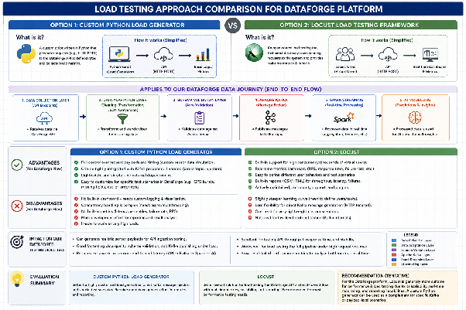
The diagram presents a comparison of two potential approaches for performing load testing within the DataForge platform: a custom Python load generator and the Locust load testing framework. Both approaches are capable of generating workload scenarios and evaluating system performance, but they differ in terms of flexibility, implementation effort, scalability, monitoring capabilities, and reporting functionality.
As illustrated in the figure, both solutions can be applied to the complete DataForge data journey, including API ingestion, data adaptation, schema validation, Apache Kafka messaging, Spark Streaming, and AI processing. The comparison highlights how each approach interacts with the platform and identifies the potential advantages and limitations associated with testing different parts of the architecture.
A custom Python load generator provides a high degree of flexibility and allows test scenarios to be tailored specifically to DataForge requirements. This may be beneficial when generating specialized sensor payloads, testing edge cases, or simulating unique data ingestion patterns. However, additional development effort may be required to implement concurrency management, performance monitoring, metrics collection, and reporting capabilities.
Locust provides a structured load testing environment with built-in support for concurrent user simulation, real-time monitoring, and performance reporting. These capabilities may simplify the execution and analysis of large-scale performance tests. At the same time, certain highly specialized testing scenarios may require additional customization depending on the specific requirements of the DataForge architecture.
The purpose of this evaluation is not to determine a preferred solution in advance, but rather to compare both approaches against the performance testing requirements of the DataForge platform. Factors such as scalability, ease of implementation, monitoring capabilities, reporting functionality, and suitability for realistic data ingestion scenarios will be considered before a final tool selection is made.

6.2.Throughput Measurement
Throughput measurement evaluates the volume of data that the DataForge platform can process within a given period of time. It is one of the primary performance metrics used to assess the scalability and processing capacity of the system.
For the DataForge platform, throughput represents the number of requests, messages, or records that can successfully pass through the data pipeline while maintaining acceptable system performance. Since DataForge is designed to process continuous streams of sensor and telemetry data, maintaining sufficient throughput is essential for supporting real-time data processing requirements.
Throughput testing will be performed by generating increasing volumes of incoming data and measuring how efficiently the platform processes these workloads. Measurements will be collected across multiple stages of the architecture, including API ingestion, Apache Kafka message publishing, and Spark Streaming data processing.
The objective of throughput measurement is to identify processing limits, detect potential bottlenecks, and verify that the platform can sustain the expected workload levels without significant performance degradation.
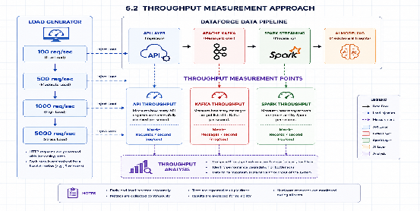
The diagram illustrates the throughput measurement approach that will be used to evaluate the processing capacity of the DataForge platform under different workload conditions. During testing, increasing levels of load are generated and injected into the system, beginning with low-volume traffic and gradually progressing to high-load and stress-testing scenarios. At each stage, throughput measurements are collected to determine how efficiently DataForge processes incoming data.
Three separate throughput measurements are performed because DataForge consists of multiple architectural layers, each with a different responsibility within the data pipeline. Measuring only overall system throughput would indicate how much data the platform can process, but it would not reveal where potential bottlenecks occur. By collecting throughput metrics independently at the API, Kafka, and Spark layers, performance limitations can be identified more accurately.
API throughput measures the number of requests successfully received and accepted by the DataForge API layer. Kafka throughput measures how many messages can be published and transferred through the messaging infrastructure per second. Spark throughput measures how many records can be processed by the real-time analytics engine within the same period. Together, these measurements provide visibility into the performance of the complete data pipeline.
Throughput measurement is a critical component of the DataForge testing strategy because the platform is designed to handle continuous streams of sensor and telemetry data. The results of these tests help determine the maximum sustainable workload that the platform can support while maintaining reliable operation. In addition, the collected metrics can be used to identify performance bottlenecks, evaluate system scalability, and verify that DataForge can satisfy the throughput requirements expected in real-world deployment scenarios.
The comparison of throughput values across the different architectural layers also provides valuable insight into the behavior of the platform under load. If one layer processes significantly fewer records than the preceding layer, this may indicate a performance bottleneck that requires optimization before deployment. Consequently, throughput measurement not only evaluates system capacity but also supports performance tuning and architectural improvement efforts throughout the development lifecycle.

6.3.Latency Measurement
Latency measurement evaluates the time required for data to travel through the DataForge platform and reach its intended destination. While throughput focuses on the volume of data processed within a given period, latency focuses on the speed at which individual records move through the system.
For the DataForge platform, low latency is essential because the system is designed to support real-time data processing and analytics. Delays introduced at any stage of the pipeline may affect downstream processing, reduce responsiveness, and impact the accuracy of time-sensitive analytics and AI-driven decision-making.
Latency measurements will be collected across multiple layers of the architecture, including API ingestion, Apache Kafka messaging, Spark Streaming processing, and end-to-end pipeline execution. These measurements will help identify processing delays, communication bottlenecks, and performance limitations under different workload conditions.
The objective of latency measurement is to ensure that DataForge can process incoming sensor and telemetry data within acceptable response times while maintaining reliable real-time operation.
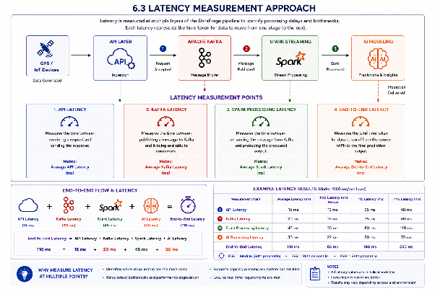
The diagram illustrates the latency measurement strategy that will be used to evaluate the responsiveness of the DataForge platform. Unlike throughput measurement, which focuses on the volume of data processed, latency measurement focuses on the time required for data to travel through the system and reach its destination. By measuring latency at multiple points in the architecture, it becomes possible to identify processing delays, communication bottlenecks, and performance limitations that may affect real-time operation.
As shown in the diagram, latency is measured independently at the API layer, Apache Kafka messaging layer, and Spark Streaming processing layer. These individual measurements provide visibility into the performance of each architectural component and help determine where delays are introduced during data processing. If one layer exhibits significantly higher latency than the others, it may indicate a bottleneck that requires optimization before deployment.
In addition to component-level measurements, the DataForge testing strategy also includes end-to-end latency measurement. End-to-end latency represents the total time required for a data record to travel through the entire platform, beginning with API ingestion and ending with the final AI prediction or analytical result. This metric is particularly important because users and downstream systems experience the performance of the platform as a whole rather than the performance of individual components.
For this reason, end-to-end latency is considered one of the most important performance indicators within the DataForge testing strategy. Even if individual components perform well in isolation, small delays introduced at multiple stages can accumulate and significantly increase the overall response time of the platform. Measuring end-to-end latency therefore provides a realistic assessment of how quickly DataForge can transform raw sensor data into actionable insights.
The collected latency metrics will be used to evaluate real-time processing capabilities, verify system responsiveness under different workload conditions, and identify opportunities for performance optimization. Together, the component-level latency measurements and the end-to-end latency measurement provide a comprehensive view of system performance and ensure that DataForge can meet the timing requirements expected in real-world deployment scenarios.

7.Al Model Validation
AI model validation focuses on evaluating the accuracy, reliability, and practical usefulness of the AI-based analytics components within the DataForge platform. After data has been collected, validated, transmitted, and processed through the pipeline, the AI model is responsible for generating predictions, detecting anomalies, or supporting risk-based decision-making.
The purpose of this validation phase is to verify that the AI model produces reliable outputs when tested against representative validation data. Unlike pipeline or integration testing, which evaluates data flow and system communication, AI model validation evaluates the quality of the model’s decisions.
For the DataForge prototype, AI model validation will focus on objective performance metrics such as AUC and False Positive Rate (FPR). These metrics help determine whether the model can correctly distinguish normal records from anomalous or high-risk records while minimizing incorrect alerts.

7.1.Al Model Validation Approach
The purpose of AI model validation is to determine whether the DataForge AI model can generate accurate and reliable predictions when processing real-world data. After sensor records have successfully passed through the data collection, validation, Kafka, and Spark processing layers, the resulting features are used as input for the AI model.
The validation process compares the predictions generated by the AI model with known reference outcomes contained within a validation dataset. By comparing predicted results with actual outcomes, it becomes possible to evaluate how effectively the model identifies anomalies, risk conditions, or other target events.
For the DataForge prototype, model validation will be performed using representative datasets that simulate realistic operating conditions. These datasets will contain both normal and anomalous records, allowing the model to be evaluated across a variety of scenarios. Validation tests will assess whether the model can correctly classify records while maintaining a balance between detection capability and false alarm generation.
The validation process will focus on objective performance metrics rather than subjective evaluation. Metrics such as Area Under the Curve (AUC) and False Positive Rate (FPR) will be used to quantify model performance and provide measurable indicators of prediction quality. These metrics will support the assessment of whether the AI component is suitable for deployment within the DataForge architecture.
By validating model behavior using realistic datasets and standardized evaluation metrics, DataForge can ensure that AI-driven outputs remain reliable, explainable, and consistent with the overall goals of the platform.
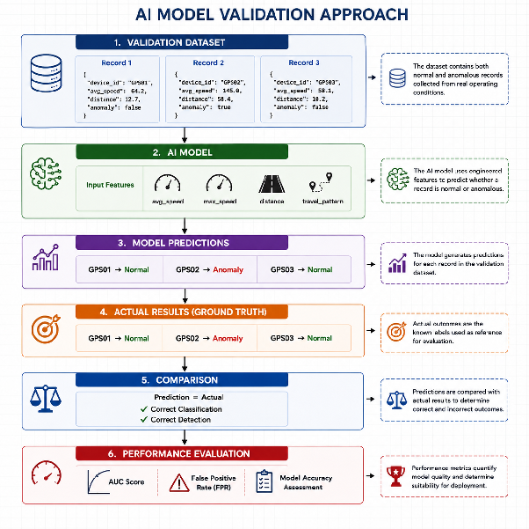
The diagram illustrates the AI model validation process used within the DataForge platform. After data has been collected, validated, transmitted through Apache Kafka, and processed by Spark Streaming, the resulting features are used to create a validation dataset containing both normal and anomalous records. This dataset serves as a controlled benchmark for evaluating the performance of the AI model under realistic operating conditions.
During validation, the AI model receives engineered features such as average speed, maximum speed, travelled distance, and movement patterns. Based on these inputs, the model generates predictions indicating whether a record represents normal behaviour or a potential anomaly. These predictions are then compared against the actual known outcomes contained within the validation dataset, commonly referred to as the ground truth.
The comparison stage is a critical part of the validation process because it provides an objective method for determining whether the model is making correct decisions. By comparing predicted classifications with actual outcomes, it becomes possible to identify both successful detections and incorrect predictions. This evaluation ensures that model performance is measured using verifiable evidence rather than subjective judgement.
The final stage of the validation process focuses on performance assessment through quantitative evaluation metrics. In the DataForge testing strategy, particular emphasis is placed on metrics such as Area Under the Curve (AUC) and False Positive Rate (FPR). These metrics provide insight into how effectively the model distinguishes normal records from anomalous records while minimizing incorrect alerts.
AI model validation is an essential part of the overall DataForge testing strategy because the reliability of downstream business insights depends directly on the quality of the model’s predictions. Even if the data pipeline functions correctly, inaccurate AI predictions can reduce the practical value of the platform. By validating model behaviour against representative datasets and measurable performance metrics, DataForge can ensure that its AI-driven outputs remain reliable, consistent, and suitable for real-world deployment scenarios.

7.2.AUC Measurement
Area Under the Curve (AUC) is one of the most widely used metrics for evaluating the performance of classification models. Within the DataForge platform, AUC is used to measure how effectively the AI model can distinguish between normal records and anomalous records.
Unlike simple accuracy measurements, AUC evaluates the model's ability to rank anomalous events higher than normal events across different decision thresholds. This provides a more comprehensive assessment of model performance, particularly when datasets contain an uneven distribution of normal and anomalous observations.
For the DataForge prototype, AUC measurement will be performed using the validation dataset described in the previous section. The AI model will generate a prediction score for each record, indicating the likelihood that the record represents an anomaly or high-risk condition. These scores will then be compared with the known ground truth labels contained within the validation dataset.
A higher AUC value indicates that the model is better at separating anomalous records from normal records. An AUC value of 0.5 represents random guessing, while an AUC value closer to 1.0 indicates excellent discrimination capability. The objective of this measurement is to verify that the AI component can reliably identify abnormal patterns while minimizing classification errors.
AUC measurement is particularly important for the DataForge platform because anomaly detection and risk assessment depend on the model's ability to correctly prioritize potentially problematic events. A strong AUC score provides evidence that the AI model can effectively support downstream analytics and decision-making processes.
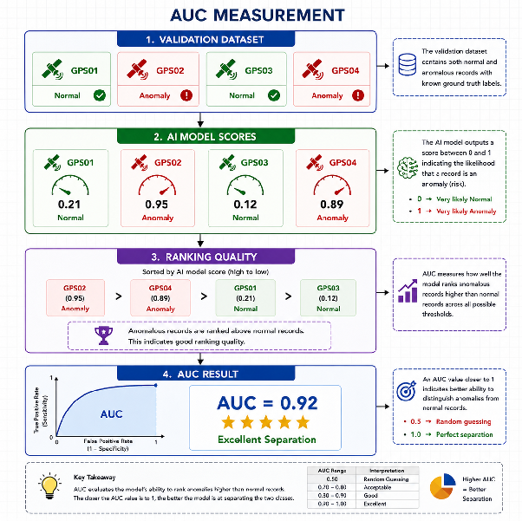

The diagram illustrates how AUC (Area Under the Curve) is used to evaluate the ability of the DataForge AI model to distinguish anomalous records from normal records. The validation dataset contains both normal and anomalous examples with known labels. The AI model assigns a score between 0 and 1 to each record, where higher scores indicate a higher likelihood of an anomaly.
The records are then ranked according to their prediction scores. In this example, the anomalous records (GPS02 and GPS04) receive the highest scores and are ranked above the normal records (GPS01 and GPS03). This demonstrates that the model is successfully separating the two classes.
AUC measures the quality of this ranking process across all possible classification thresholds. An AUC value close to 1.0 indicates strong discrimination capability, while an AUC value close to 0.5 suggests performance comparable to random guessing. In this example, the model achieves an AUC score of 0.92, indicating excellent separation between normal and anomalous records.
For the DataForge platform, AUC is an important validation metric because it evaluates whether the AI model can reliably prioritize potentially risky or abnormal events before they are used for downstream analytics and decision-making.

7.3.False Positive Rate(FPR) Measurement
False Positive Rate (FPR) measures the proportion of normal records that are incorrectly classified as anomalies by the AI model. While detecting anomalous behaviour is an important objective of the DataForge platform, excessive false alarms can reduce the practical usefulness of the system and decrease user confidence in the generated predictions.
During validation, the AI model predictions will be compared against the known ground truth labels contained within the validation dataset. Whenever a normal record is incorrectly classified as anomalous, a false positive event is recorded. The False Positive Rate is then calculated by comparing the number of false positive predictions to the total number of actual normal records.
For the DataForge platform, maintaining a low FPR is particularly important because unnecessary anomaly alerts may trigger additional investigation, consume operational resources, and reduce trust in the analytics pipeline. A model that produces too many false alarms may be difficult to use effectively, even if its overall detection capability is high.
FPR measurement therefore complements AUC measurement by providing additional insight into model behaviour. While AUC evaluates the model's ability to separate normal and anomalous records, FPR evaluates how often the model incorrectly flags legitimate activity as suspicious. Together, these metrics provide a balanced assessment of AI model performance.
The objective of FPR measurement is to ensure that the DataForge AI model can detect genuinely anomalous behaviour while minimizing unnecessary alerts and maintaining reliable decision support.
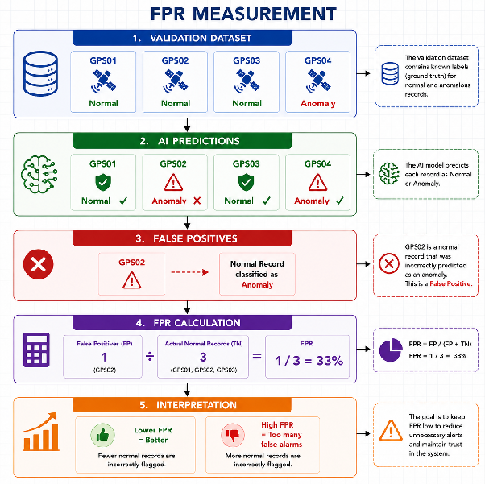
The diagram illustrates the concept of False Positive Rate (FPR) and its role in evaluating the reliability of the DataForge AI model. A false positive occurs when the model incorrectly classifies a normal record as an anomaly. In other words, the system generates an alert even though no abnormal behaviour is actually present.
In the example shown, GPS02 is a normal record within the validation dataset. However, the AI model predicts it as an anomaly. This prediction is therefore counted as a false positive. While the model successfully identifies the actual anomaly (GPS04), it also generates an unnecessary alert for GPS02.
The False Positive Rate measures how often these incorrect alerts occur relative to the total number of normal records. A high FPR indicates that the model is frequently flagging legitimate behaviour as suspicious, while a low FPR indicates that the model is able to distinguish normal activity from abnormal activity more accurately.
For the DataForge platform, controlling the False Positive Rate is particularly important because excessive false alarms can reduce confidence in the system and create unnecessary operational workload. If normal sensor activity is repeatedly classified as anomalous, users may begin to ignore alerts or spend valuable time investigating events that do not require attention.
Unlike AUC, which evaluates how well the model separates anomalies from normal records, FPR focuses specifically on the cost of incorrect anomaly detections. Together, these metrics provide a balanced assessment of model performance by measuring both detection capability and the frequency of false alarms. The objective is therefore to maximize anomaly detection performance while keeping the False Positive Rate as low as possible.

8.Test Reporting
The DataForge testing process will generate several types of reports to support quality assurance and project evaluation. Test reports will include unit testing results, integration testing results, code coverage measurements, performance testing metrics, and AI model validation results. These reports will provide visibility into system quality, identify defects, and support continuous improvement throughout the development process.
Automated reports generated by pytest and pytest-cov will be used to summarize test execution results and coverage statistics. Performance testing activities will produce throughput and latency measurements, while AI validation activities will provide evaluation metrics such as AUC and False Positive Rate (FPR). Together, these reports will provide a comprehensive overview of platform reliability, performance, and prediction quality.
The reporting process ensures that test outcomes are documented in a consistent manner and that potential issues can be identified and addressed before deployment. By maintaining detailed test reports, DataForge can support traceability, quality control, and evidence-based decision-making throughout the software development lifecycle.
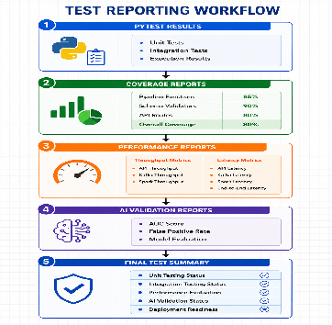
The diagram illustrates the reporting workflow used within the DataForge testing strategy. Test results generated throughout the development process are consolidated into a structured reporting pipeline. The reporting process begins with pytest execution results, which provide information about unit tests, integration tests, and overall test execution outcomes. These results are complemented by code coverage reports that measure how extensively the application components have been tested. Performance reports then summarize throughput and latency measurements collected from the API, Apache Kafka, and Spark Streaming layers, while AI validation reports provide evaluation metrics such as AUC and False Positive Rate (FPR).
The final stage combines all collected information into a comprehensive test summary that provides an overall assessment of system quality, performance, and deployment readiness. By consolidating testing outcomes into a single reporting workflow, DataForge can ensure that reliability, performance, and AI model quality are evaluated consistently across the entire platform. This reporting approach also improves traceability and provides clear evidence that testing objectives have been achieved before the system progresses to deployment or further development stages.

9.Conclusion
This testing strategy has defined a structured approach for evaluating the functionality, reliability, performance, and AI capabilities of the DataForge prototype. The strategy covers all major stages of the platform, including data ingestion, data transformation, schema validation, Apache Kafka messaging, Spark Streaming processing, performance evaluation, and AI model validation.
A combination of unit testing, integration testing, end-to-end testing, performance testing, and AI validation has been selected to provide comprehensive coverage of the platform. These testing activities ensure that individual components operate correctly, that data can move reliably through the Kafka-to-Spark pipeline, and that the complete system functions as an integrated real-time data processing solution.
Performance testing focuses on throughput and latency measurements to evaluate scalability and responsiveness under different workload conditions. In addition, AI model validation activities use objective metrics such as Area Under the Curve (AUC) and False Positive Rate (FPR) to assess the quality and reliability of AI-generated predictions.
The testing and reporting processes described throughout this document provide measurable evidence of system behaviour and support data-driven evaluation of the prototype. By combining functional testing, performance analysis, and AI validation, the DataForge project can identify defects, detect bottlenecks, improve system quality, and establish confidence in the overall architecture.
Ultimately, this testing strategy provides a foundation for ensuring that the DataForge platform can process data accurately, reliably, and efficiently while supporting future development, optimization, and real-world deployment scenarios.

